Consortium Activity

Concepts to be understood before going to workflow
Before we dive into definition for Gitlab, first we need to understand few terminologies.
Git
It is a source code distributed version control system that lets you locally track changes and push or pull changes from remote resources. It allows developers to collaborate on a project more effectively by providing tools for managing possibly conflicting changes from multiple developers.
What is Version Control System?
Version Control System - Version control systems are a category of software tools that helps in recording changes made to files by keeping a track of modifications done to the code.
Why Version Control System ?
Ex: Consider a scenario of developing software product in collaboration by a group of developers they might be located at different locations and each one of them contributes in some specific kind of functionality/features. So in order to contribute to the product, they made modifications in the source code(either by adding or removing). A version control system is a kind of software that helps the developer team to efficiently communicate and manage(track) all the changes that have been made to the source code along with the information like who made and what change has been made. A separate branch is created for every contributor who made the changes and the changes aren’t merged into the original source code unless all are analyzed as soon as the changes are green signalled they merged to the main source code. It not only keeps source code organized but also improves productivity by making the development process smooth.
What is Distributed Version Control System
Distributed version control systems contain multiple repositories. Each user has their own repository and working copy. Just committing your changes will not give others access to your changes. This is because commit will reflect those changes in your local repository and you need to push them in order to make them visible on the central repository. Similarly, When you update, you do not get other’s changes unless you have first pulled those changes into your repository.
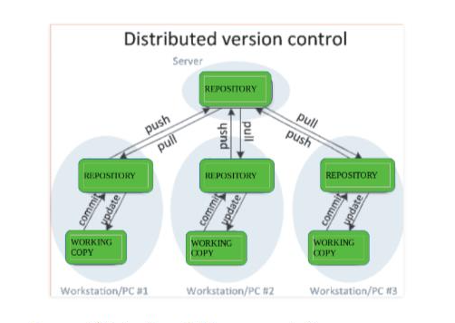

To make your changes visible to others, 4 things are required:
• You commit
• You push
• They pull
• They update

GitHub, GitLab and Bitbucket – Platforms to host Git

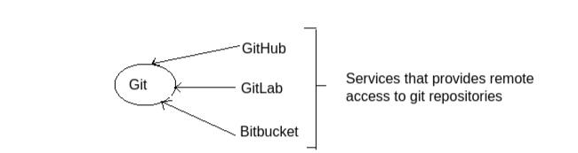

GitHub
• GitHub is a repository hosting service tool that features collaboration and access control.
• GitHub allows developers to change, adapt and improve software from its public repositories for free, but it charges for private repositories, offering various paid plans
• Each public or private repository contains all of a project's files, as well as each file's revision history.
• Repositories can have multiple collaborators and can be either public or private.
• There is no built-in continuous integration in GitHub. It is provided by third-party vendors.
GitLab
• GitLab is a repository lets its team of web developers collaborate on codes.
• It provides unlimited number of private and public repositories for free
• It is self-hosted Git repository management system that keeps the user code private and easily deploy the changes of the code.
• GitLab offers 100% built-in integration. They favor their own integration tools with continuous developments i.e. issue trackers, Continuous Integration, Continuous Delivery
Since both GitHub and GitLab are version control systems (VCS), it can be difficult to choose one of the two. GitLab is not an alternative for GitHub, rather GitHub is more popular amongst the developers as it holds millions of repositories. So based on the requirements we need to choose between these two.

What is CI/CD?
Continuous Integration
• It is a software development method where team members integrate their work at least once a day.
• Every integration is checked by an automated build to detect errors.
• In Continuous Integration after a code commit, the software is built and tested immediately.
• In a large project with many developers, commits are made many times during a day. With each commit code is built and tested. If the test is passed, build is tested for deployment. If the deployment is a success, the code is pushed to Production.
• In simple terms CI is an approach of testing each change to codebase automatically.
Continuous Delivery
• Continuous Delivery is a software engineering method in which a team develops software products in a short cycle.
• It ensures that software can be easily released at any time.
• The main aim of continuous delivery is to build, test, and release software with good speed and frequency.
• In simple terms CD is an approach to obtain changes of new features, configuration, and bug fixes.

Jenkins
• Jenkins is the most popular open source CI/CD tool on the market today and is used in support of DevOps.
• Jenkins is used to build and test your product continuously, so developers can continuously integrate changes into the build.
How does it work?
Jenkins triggers a build upon every commit to the source code repository, typically to a development branch.
JIRA
• This software is used for bug tracking, issue tracking, and project management.
• The JIRA dashboard consists of many useful functions and features which make handling of issues easy.

Merge Request
• A merge request (MR) is the basis of GitLab as a code collaboration and version control. When working in a Git-based platform, you can use branching strategies to collaborate on code.
• Branching is especially important when collaborating with others, avoiding changes to be pushed directly to the default branch without prior reviews, tests, and approvals.
• A repository is composed by its default branch, which contains the major version of the codebase, from which you create minor branches, also called feature branches, to propose changes to the codebase without introducing them directly into the major version of the codebase.
• The branch you added your changes into is called source branch / feature branch while the branch you request to merge your changes into is called target branch.
• Merge requests are created if you are working in a feature branch and wants to merge your change in main branch(eg. Master branch). The merge requests serves as a code review tool and if your code reveals shortcomings/issues anyone(usually other developers) can commit and push a fix.
• The target branch can be the default or any other branch, depending on the branching strategies you choose.
• Life Cycle : You create a branch, fix some issue or add a feature, create a pull/merge request, then you assign it to someone, he/she will review your fix and can accept/reject the pull/merge request.
Git Squash
• Git squash means combining multiple commits into one.You can do this at any point in time (by using Git's "Interactive Rebase" feature), though it is most often done when merging branches.
• Squashing is mainly used to condense a large number of commits to make it to a small number of meaningful commits. So that we can make the git history clearer.
• There is no such thing as a stand-alone git squash command. Instead, squashing is rather an option when performing other Git commands like interactive rebase or merge.

Workflow

Tools Required:
• GitLab - code.autosar.org
• JIRA software - jira.autosar.org
• JENKINS platform – ci.autosar.org

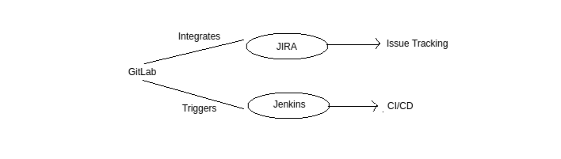

Gitlab has JIRA integration that allows Jira software to be used as an issue tracker for the planning stage.
• From GitLab, we can trigger a Jenkins build when code is pushed to a repository, or when a merge request is created. In return, the Jenkins pipeline status is shown on merge requests widgets and on the GitLab project’s home page.

Steps:
1. Login to JIRA software through the link mentioned above with credentials.
2. Click on Issues → My open issues → Displays all the issues which are assigned to you which are in progress or to do.
And also in the left side of the window click on the type of the issue you want to view. ( Open issues, Done issues, Viewed recently, … )
3. Click on the particular issue which you want to view.
4. The particular issue is displayed with details, description of the issue, comments etc .. as shown in the below figure
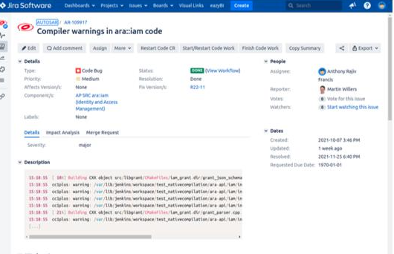

5. Go through the description of the ticket, whether it is error or warning or any code change, what is the path of that file where that errors/warnings are present or the file where the changes to be made.
6. In order view that particular error or warning in the apd code ( present in the system) perform native compilation where you can build log files and can view the warnings as shown in the below figure
Refer below link for native compilation
https://lnttsgroup.sharepoint.com/:w:/r/sites/LADAR/_layouts/15/Doc.aspx?sourcedoc=%7BDC0B859B-3AD0-48B7-9E42-
D7563FA2FD11%7D&file=8.%20Compile%20on%20native%20host.docx&action=default&mobileredirect=true
